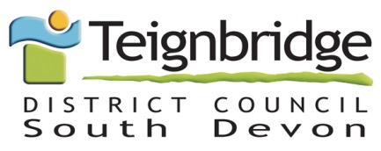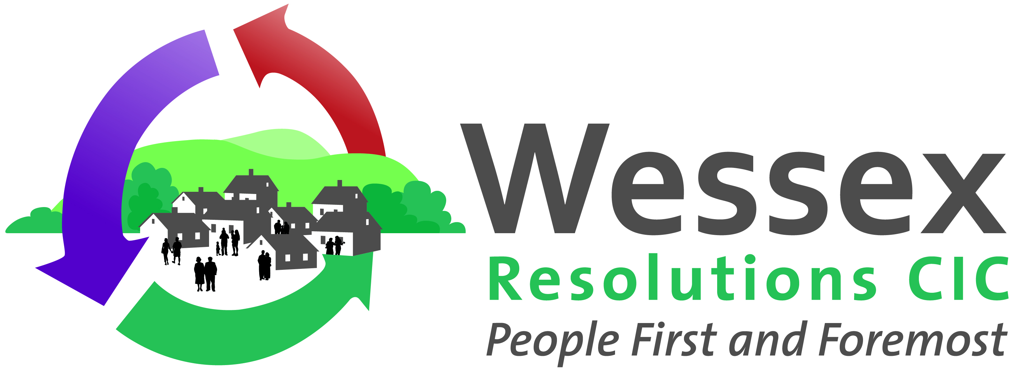
Council supporting homeowners with essential home repairs
Teignbridge District Council is taking the opportunity to remind homeowners about their loan scheme to enable homeowners to fund essential home repairs. The scheme has been developed to keep people warm, safe and dry in their homes.
A variety of works can be considered such as roof and thatch repairs, boiler and other heating system replacement or installation, replacing rotten or draughty windows, structural repairs or electrical or plumbing work to name a few. The scheme has been set up to enable eligible homeowners to choose their own contractor and there are a variety of loan products available to suit individual needs and means.
The scheme is delivered through Wessex Resolutions CIC a not-for-profit, Responsible Finance provider in close partnership with the council. The partnership has been running for over ten years across West Dorset and has helped a huge variety of homeowners. A recent client said "For all my adult life I have not had central heating and, now I'm getting a bit older, it will be nice to feel warm in the winter."
Through providing loans, the council are ensuring funds for homeowners are sustainable meaning that every repayment goes back into the council pot to lend to homeowners into the future. A loan funded by the council could help spread the cost of home repairs but let you enjoy the benefit right away.
For more information, call Wessex Resolutions direct on 01823 461099, visit www.wrcic.org.uk or email enquiries@wrcic.org.uk.
Loans have a fixed interest rate and typical 4.2% APR and are subject to status. Missing future payments could affect your credit rating and ability to obtain credit in the future. Wessex Resolutions CIC may insist on loans being protected at the Land Registry by a Title Restriction.
Wessex Resolutions C.I.C.: a community interest company limited by guarantee, registered in England, company number 4512225. Registered address: Heatherton Park Studios, Bradford on Tone, Taunton TA4 1EU. Wessex Loans and Wessex Home Improvement Loans are trading names used by this company. Wessex Resolutions C.I.C is authorised and regulated by the Financial Conduct Authority (675263) for credit and debt-related regulated activities.

